Customer Segmentation Using Unsupervised Learning - PART A
Objective
The objective of this analysis was to identify groups of similar customers in an online supermarket dataset where no target variable was provided. Clustering was used to segment customers based on their purchasing behavior, and profiling was performed to understand the distinctive characteristics of each group (Python, 2021).
Dataset Overview and Preparation
The dataset contained 30,000 order records with 14 variables, including customer ID, order details, shopping time, discounts, and percentage spend across eight product categories. There were no missing values, confirming good data quality.
As there was difference in patterns over a long period of time in the order level, we rolled the data on to the customer level, which was 10,239 unique customers. The per-customer metrics that we calculated include: avg items per order, avg discount, favourite time shopping, and avg amount spending on each category. We also computed a category entropy score to check the extent to which the buying was niche or diverse on the customer (Aladzuz et al, 2022). All features were standardized in such a way that they all would be weighted equally in the clustering (Python, 2021).
Clustering Approach and Model Selection
We selected K-Means, as it is simple, easy to describe and serves with numbers. Silhouette scores were computed to determine the number of clusters that were the most appropriate (Wu, 2021). The silhouette analysis informed us that the value of k that scored the highest (0.282) was 3 implying that there was a balance between the separation and cohesion. Other statistics such as Davies-Bouldin, Calinski-Harabasz were congruent with that choice (Wu, 2021).
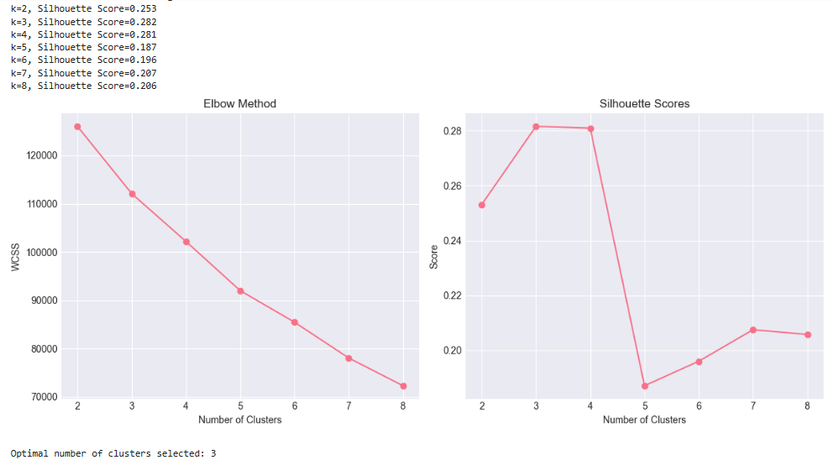
Results of silhouette score using various values of k.
Cluster Distribution
The final clustering resulted in three distinct customer segments:
Cluster 0 -8163 customers (the majority of the cohort)
Cluster 1 -408 customers (a small niche)
Cluster 2- 1,668 customers (niche group)
That informs us that the majority of shoppers follow a general pattern, although there are a few smaller and distinct categories (Aladzuz et al, 2022).
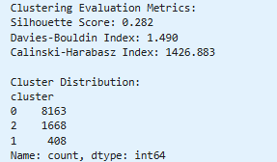
Evaluation metrics clustering and end-result distribution.

Cluster Profiling and Key Insights
Cluster 0 – Regular Multi-Category Shoppers
The entire purpose of the project in other words was simply to cut the data that we had of our online supermarket into meaningful clumps, we did not explicitly have a target variable of interest to us, which in fact made it a fun exercise in unsupervised learning. K-Means was also used to cluster the customers by purchasing patterns and then returned in a process of profiling each customer cluster so we could question them about what is fueling the habits (Python, 2021). In essence, these are the people that constitute the bread-and-butter of the customer base; the ones that you would want to target with blanket promotions or cross-category pushes as they are the most open.
Insight: These customers are core customer base and will be appropriate when it comes to general promotions and cross category marketing.
Cluster 1 – Discount-Driven Bulk Food Buyers
This group represents the least but them all concern score-carded savings. It is a group who seizes huge discounts, piles up pounds of food and groceries, and pretty much use all their money on food. Their category entropy is near zero in nature, and hence there is evident stick-to-food inclination (Classic clustering result). I would indicate that the most important tactic is ensuring that they remain locked to bulk buying and reward arrangements - they are the bargain hunter type.
Insight: These are high price-sensitive and picture-driven customers. The most effective ones will be targeted bulk food discounts or loyalty-based offers.
Cluster 2 – Baby & Beauty Focused Occasional Shoppers
These shoppers will always be the high-and-dry type and will visit regularly once or twice a month but will go heavy on baby and beauty lines. They are a niche bundle with an extremely small cross-product spread, and thus deactivating them with baby-care offers, beauty boxes, or selfie-friendly subscription notifications might be the jackpot (Wu, 2021).
Insight: This category is the best target in one-on-one campaigns involving baby products and beauty cosmetics; subscription-based or reminder-based offers (Wu, 2021).
Conclusion
The analysis of the cluster identified three types of consumer segments and each consumer segment had its own purchasing rhythm. These insights provide us with a guide on how we can be smarter in our marketing strategies, unique promotions, and smarter inventory insights. Because we employed K-Means and customer level aggregation, the obtained results were not only easy to read but also easy to implement in practice, a definite success of future projects based on data.
References
Aladžuz, A., Delalić, A., & Šćeta, L. (2022, May). Cluster Analysis in Python: An example of market segmentation. In International Conference “New Technologies, Development and Applications” (pp. 1032-1041). Cham: Springer International Publishing.
Wu, B. (2021, August). K-means clustering algorithm and Python implementation. In 2021 IEEE International Conference on Computer Science, Artificial Intelligence and Electronic Engineering (CSAIEE) (pp. 55-59). IEEE.
Python, W. (2021). Python. Python releases for windows, 24.

